INSIGHTX
STUDENT PERFORMANCE
ANALYTICS SYSTEM
PROJECT DOCUMENTATION

Student Name | Meghana
Course | Python with AI
Project Type | Student Performance Analytics
Submission Deadline | 15 October 2026
A Python-based system for organizing student marks,
calculating performance measures, and presenting academic analysis.

1. Project Title
INSIGHTX – Student Performance Analytics System
Student: Meghana
Course: Python with AI
Project repository: https://github.com/meghana012121/student-performance-analytics

2. Objective
The objective of INSIGHTX is to analyze student academic records in a clear and organized way. The program reads a CSV dataset, calculates totals and average marks, assigns grades, checks pass/fail status, ranks students, and summarizes subject and attendance performance. The interactive menu helps a user explore these results without needing to inspect the source code.

3. Technologies Used
Technology | Purpose in the project
Python | Main programming language; conditions, loops, functions and application flow.
Pandas | Loads the CSV dataset into a DataFrame and supports filtering, sorting and analysis.
NumPy | Calculates numerical values such as totals, averages, minimums, maximums and rankings.
Matplotlib | Creates charts for subject averages, student performance, grade distribution, and attendance versus average marks.
CSV | Stores the sample student records in students.csv.
VS Code | Used to edit and run the project.
Git and GitHub | Tracks project changes and hosts the public repository.

4. Dataset Description
The project uses students.csv, a sample dataset containing 20 student records from the CSE department. It includes student identification details, marks in four subjects, and attendance percentage.
- Student_ID — unique identifier for each record.
- Name — student name.
- Department — department field (CSE in the current sample dataset).
- Python, SQL, Mathematics, AI — subject marks.
- Attendance — attendance percentage.
The dataset is provided as a sample for demonstrating the program. It should not be treated as official institutional student data.

5. Implementation

5.1 Loading and preparing data
The main program uses Pandas to read students.csv. It processes each row and collects the derived values into lists before adding them as columns to the DataFrame.

5.2 Calculating marks and averages
For each student, the four subject marks are placed in a NumPy array. Reusable functions calculate the total and mean. The average is rounded to two decimal places for display.

5.3 Grade and pass/fail rules
The grade is assigned using the average mark. The current rule is: A+ for 90 and above; A for 80–89.99; B for 70–79.99; C for 60–69.99; D for 50–59.99; and F below 50.
A student is marked Pass only when every subject mark is at least 40 and attendance is at least 75%. Otherwise, the result is Fail.

5.4 Ranking and analysis
The DataFrame is sorted by average marks in descending order, and a rank is assigned to each student. The program also calculates the class average, highest and lowest student averages, pass/fail counts, subject averages, and the best-performing subject.

5.5 Interactive menu and charts
The interactive terminal menu provides options for the class dashboard, top performers, student search by ID, subject analysis, attendance analysis, and charts. The charts module uses Matplotlib to visualize selected results.

5.6 Source-file organization
- main.py — loads the data, calculates derived fields, and displays the interactive menu.
- functions.py — contains reusable functions for totals, averages, grades, pass/fail checks, performance levels, and strongest/weakest subjects.
- charts.py — contains chart functions.
- students.csv — sample dataset.
- README.md — repository overview, features, setup instructions, and project structure.
- .gitignore — prevents Python cache files in __pycache__ from being tracked.

6. Key Features
- Student total and average marks calculation.
- Automatic grade assignment and pass/fail classification.
- Ranking based on average marks.
- Top-five student performance display.
- Search for an individual student using Student ID.
- Subject-wise average comparison and best-subject identification.
- Attendance summary using the 75% threshold.
- Four visualizations: subject averages, top-ten student averages, grade distribution, and attendance versus performance.

7. Output and Screenshots
Insert screenshots of the program's actual output in this section before final submission. Capture the Class Dashboard, Top Performers, Search Student, Subject/Attendance Analysis, and at least one chart.

Screenshot 1 — Class Dashboard
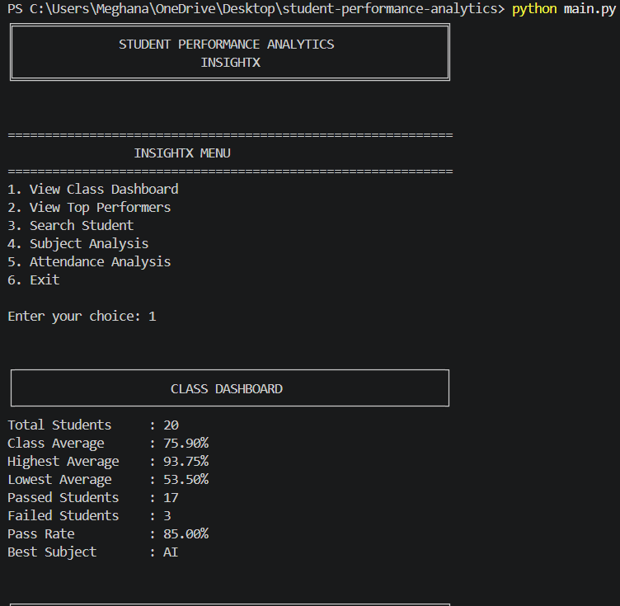

Screenshot 2 — Top Performers

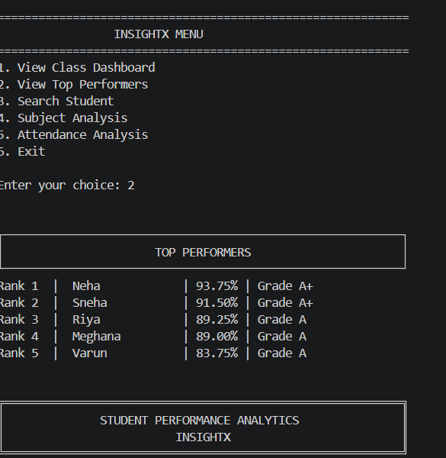

Screenshot 3 — Student Search
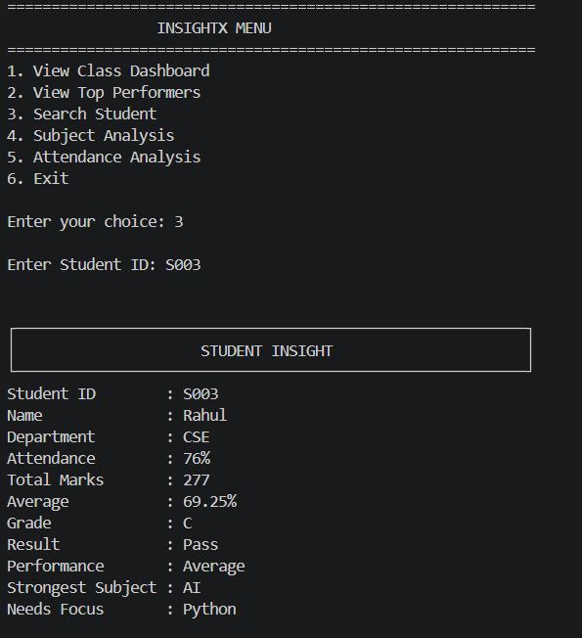

Screenshot 4 — Visual Analytics
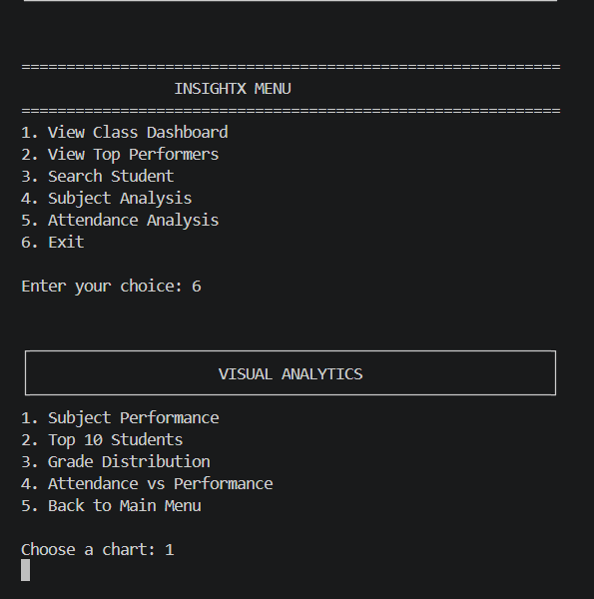

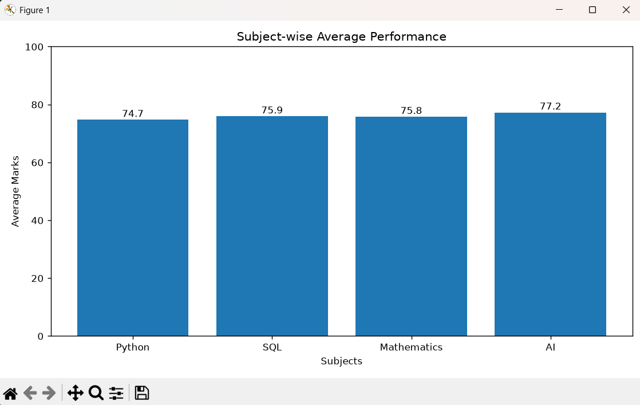

8. Final Outcome
INSIGHTX brings student marks and attendance into a single analysis workflow. It produces totals, averages, grades, pass/fail results, rankings, subject summaries, attendance statistics, and charts. The menu-based interface lets a user access these features from the terminal. The system demonstrates practical use of Python fundamentals, NumPy numerical operations, Pandas data handling, and Matplotlib visualization.
Note: Final numeric findings (such as the class average, number passed, and best subject) should be copied from a fresh run of main.py after verifying the current dataset.

9. Challenges and Learning
- Organizing the program into a main file, reusable calculation functions, a chart module, and a CSV dataset.
- Using NumPy arrays to perform numerical calculations on subject marks.
- Using Pandas to sort, filter, and summarize student records.
- Defining clear grading and pass/fail rules and applying them consistently.
- Building a menu that allows users to choose different analyses.
- Creating charts to communicate patterns visually.
- Using Git commands to initialize a repository, create a commit, ignore generated cache files, and push the project to GitHub.
This project helped reinforce the relationship between Python fundamentals and practical data analysis.

10. GitHub Repository
Repository URL: https://github.com/meghana012121/student-performance-analytics
The repository is public. It contains the project source files, sample dataset, README, and .gitignore file.

